DOCUMENT ANALYSIS FOR EACH PLATFORM

1. **Shaadi.com**

An exclusively open website for meeting loved ones and for marriage proposals. This website interface allows anyone to connect for any gender with a specified age limit.

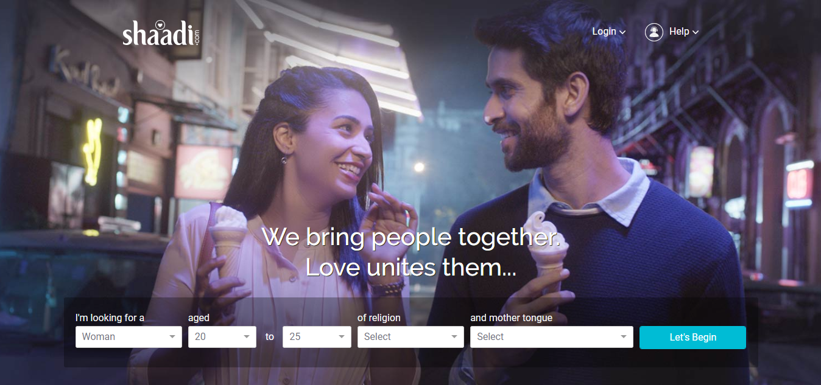

Before setting the process, an account can be made by signing up in the website. This would then the website to match the details and send regular updates.

Features:

* The I’m looking for a toolbox allows people to specify the gender they are looking for.
* The age option gives the searcher an expansive opportunity to search for any gender with respect to their age.
* Once that is set, the religions can be set with their mother tongue.
* Once the Let’s Begin Search button is enabled, suitable matches are being shown. A click on the perfect one and your connection is made.

To improve the experience in a mobile phone, the feature of ShaadiMeet Application is present as an application in Google Play. This would enable the connected match to call their loved ones and have a free streaming session with no interruptions. The same buttons are being set in the mobile application also.

Once the relation is set, stories can be set out into popular blogs and then the results are posted in their websites for the public to view.

1. **CISCO Web**

A website designed for a smooth streaming video call and conferencing. Managed by CISCO, the unique video conferencing website is designed to facilitate companies to manage their discussions online and track progress from home.

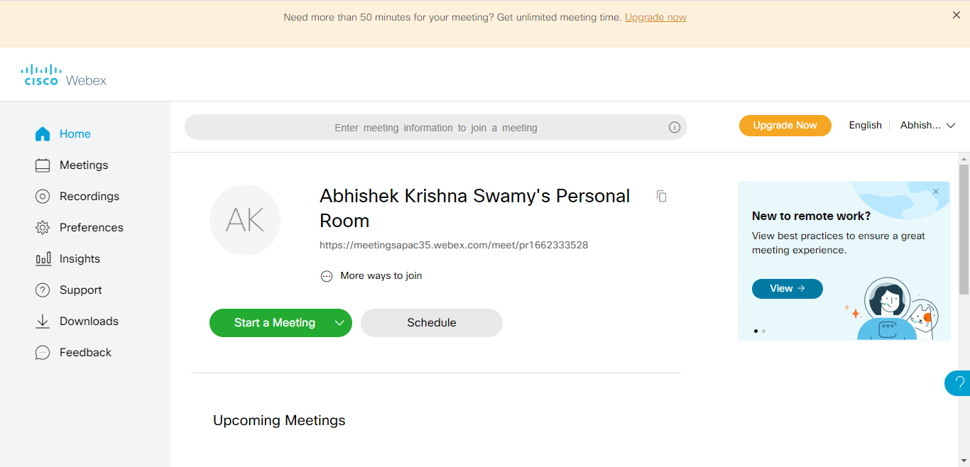

Using a personal id, we can create a workspace and web zone for scheduling and creating meetings. At appropriate date and time, the meetings can be created for a free time of 50 minutes, after which an upgrade can be made for a longer duration.

Features:

* The Meetings toggle button can be used to set a meeting for a certain date and time, which can be recorded.
* The recorded meeting can be played in the Recordings button.

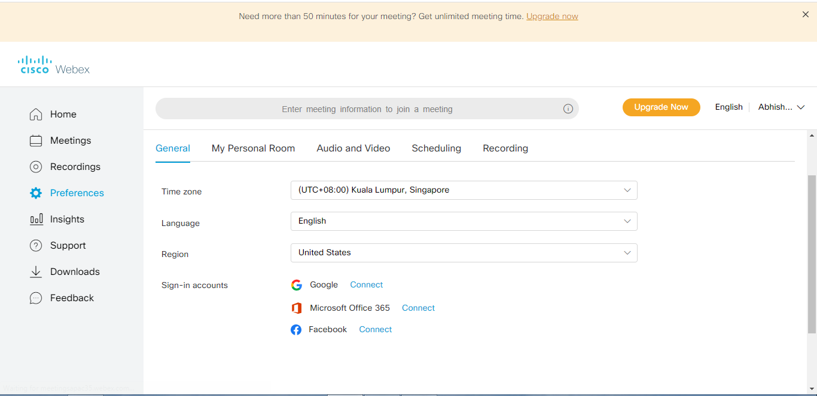

* Using the preferences option, we can set our own outlook on how the meeting is supposed to go.
* Insight give you a detailed report on how many viewers have attended the meetings and gives a detailed statistics with respect to your meetings.
* The Download option allows us to download the required software to allow a smooth meeting. These ca be different versions of Office required to streamline the integration process smooth.
* The support and feedback mechanism designed for user comfort allow technical support at times of need.

1. **Medium**

Medium a website interface is designed solely for information acquisition of a wide variety of topics. Starting from the rudimentary to the most sophisticated topics; all sorts of content are available in this website.

Firstly, an account can be created by signing up with a google account, after which different Genre can be accessed.

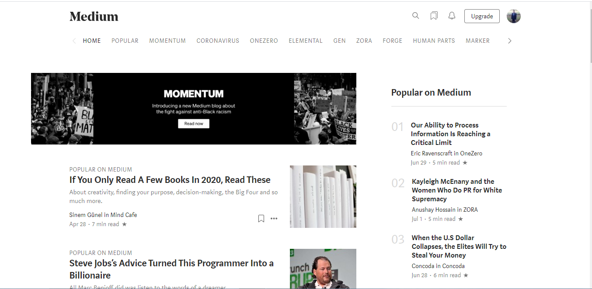

**Features:**

* The different boxes indicate different topics that can be read. A click and these topics can be viewed.
* Certain articles can be obtained by upgrading the package. This can be done using the upgrade option.
* Using a medium content, blogs can also be exported which can then be posted once deemed good for publishing.

The page also allows you to play with your minds. The option to write on different topics can be made possible in the write option. Once posted, the editorials scan the content which is then sent across and posted in the medium digest for viewers to see across the world.



Features:

* Once the medium partner program is joined, writers can post their contents online and let others view it.
* This writing can be edited by experts in the editorial column.
* Once an adequate number of readership is obtained, there would be a revenue for your writing piece.

1. **ZOOM**

An online video conferencing application, zoom allows users to interact with people around the world with its simplified usage. This has also been specialized in terms of conducting classes, sharing documents, for webinars and other multipurpose applications.

Some of the features include:

* Specialized waiting rooms in times of crowd.
* Specific zones for talking with multiple people at the same time.
* Mute and unmute participants, with accessing the participants present at the same time.
* Disabling video camera facility and locking the meetings.
* Facilitating data sharing with the purpose of screen sharing where documents can be displayed among people.

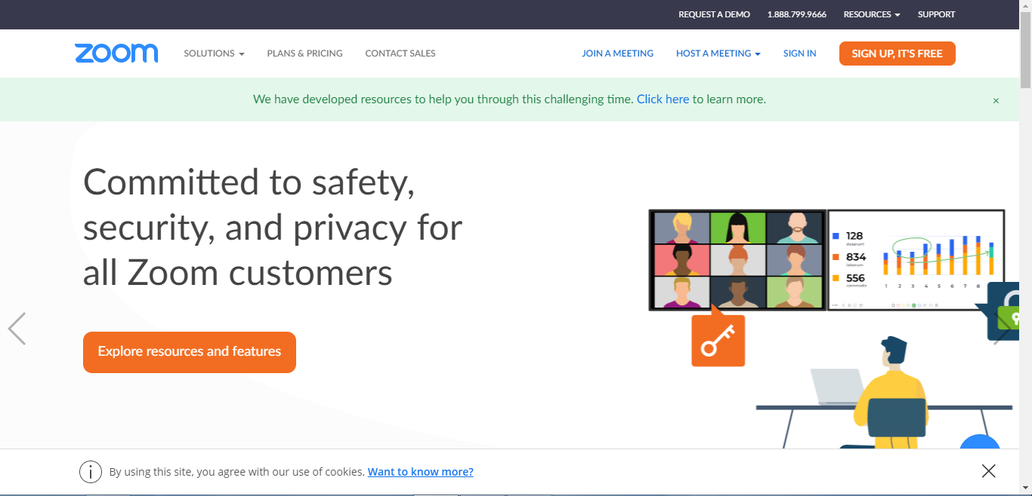

* A unique chatting room can be created by scheduling a meeting.
* 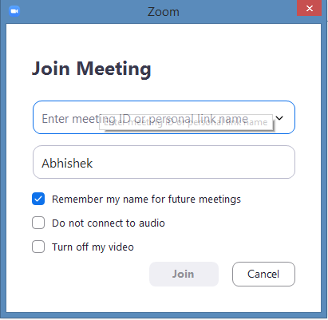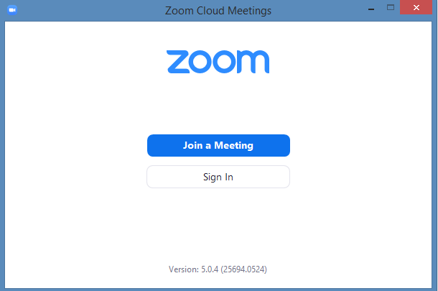This can enable the user enter the specified room for conferencing.
* The facility of waiting rooms can be enabled when the user is inside the meeting room with different people.

1. Telegram

A trending social media website, telegram allows users to sign in with their respective mobile numbers and experience a unique experience in the

LINE

Line is a freeware app for instant communications on electronic devices such as smartphones, tablet computers, and personal computers. Line users exchange texts, images, video and audio, and conduct free VoIP conversations and video conferences.

* We can message in a group or a person

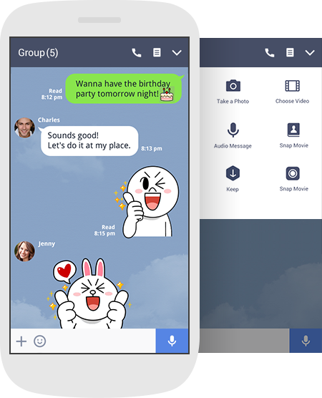

* We can do video or voice call



* We can send them photos, videos and voice message in a chat

